Case 10-MEX-Olmec-Were Jaguar- Plaque-Openwork-Steatite-1100 BCE





Olmec-Plaque-Openwork-Steatite-1100 BCE

**Case no.: 14**

**Accession Number:**

**Formal Label:** Olmec-Plaque-Openwork-Steatite-1100 BCE

**Display Description:**

This openwork plaque was to have been worn over the right eye as part of a jaguar transformation mask which emphasized feline wrinkles around the nose, upcurving lips and bared teeth. As part of a transformation mask it would have been the frame for the right eye since there are five drilled holes that would have secured it to some type of leather or textile cord. The wearer would have assumed a new *spiritual identity*, perhaps that of the were-jaguar ancestor, because the Olmecs believed that, in the distant past, a union between a woman and a jaguar produced an earlier race of were-jaguars. The Olmecs worked mainly in stone and used serpentine to suggest the dark aspect of the were jaguar conversion.

**Display Description:**

This is a were-jaguar transformation maskette or jaguar theriomorph maskette (of the right eye) that is designed to show the transformation of a shaman into a *spiritual jaguar being*. Accordingly, it emphasizes the feline wrinkles above the nose and the curving lips. It was found in Campeche in the early 60's when it was imported to the US. It depicts a jaguar shaman with an elongated skull. It was probably as a pendant which devotees were believed to have been given a new identity, perhaps that of were-jaguar ancestors, because the Olmecs believed that, in the distant past, a union between a woman and a jaguar produced an earlier race of were-jaguars. The Olmecs worked mainly in stone and used jade to suggest the life-giving aspect of the were-jaguar theriomorphic conversion.

**LC Classification:**

**Date or Time Horizon:** 1100 BCE

**Geographical Area:** possibly La Venta area

**Map:**

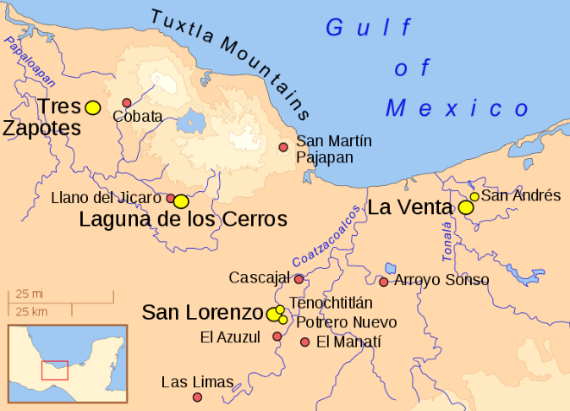

**GPS coordinates:**

**Cultural Affiliation:** Olmec

**Medium:** jade

**Dimensions:** H 2 ½ in, W 1 7/8 in ,T 7/8 in

**Weight:**

**Condition: original.**

**Provenance:**

**Discussion:**

The Olmecs, the earliest known settled civilization of Central America, lived in the low-lying Gulf Coast area of what is now Mexico in about 1200-400 BCE at sites such as San Lorenzo, Tres Zapotes, Laguna de los Cerros and La Venta.

These and the other Olmec centers were well planned and included many of the features that would be associated with later civilization in Central America including the Mexica (Aztecs) and Maya. Alongside impressive public spaces and large platform-mounds made of earth, there is evidence of a ceremonial ball game and complex astrological calendars.

**References:**

Bernal, Ignacio. 1976. The Olmec World. Berkeley, CA: University of California Press.

Campbell, Lyle and Terrence Kaufman. “A Linguistic Look At The Olmec.” American Antiquity. Vol. 41, January, 1976, p. 80-89.

Coe, Michael D. 1994. From The Olmecs To The Aztecs. 4th ed. London: Thames & Hudson, 1994.

— . 1996. The Olmec World: Ritual and Rulership. Princeton, NJ: The Art Museum, Princeton University.

Drucker, Philip, Robert F. Heizer, and Robert J. Squier.1959. “Excavations At La Venta, Tabasco, 1955.” Bureau Of American Ethnology. Bulletin 170.

Grove, David C. 1984. Chalcatzingo: Excavations On The Olmec Frontier. London: Thames & Hudson.

Luckert, Karl W. 1976. Olmec Religion: A Key To Middle America And Beyond. Norman, OK: University of Oklahoma Press.

Miller, Mary and Karl Taube. 1993. The Gods And Symbols Of Ancient Mexico And The Mava: An Illustrated Dictionary of Mesoamerican Religion. London: Thames & Hudson.

Sharper, Robert J. and David C. Grove, eds. 1989. Regional Perspectives On The Olmec. NY: Cambridge University .

Soustelle, Jacques. 1984. The Olmecs: The Oldest Civilization In Mexico. Garden City, NY: Doubleday & Company.